Yosemite Falls, River View, 2637 Feet
Carleton E. Watkins | ca. 1861 | Record IMG-NAM0008

1. Original Image
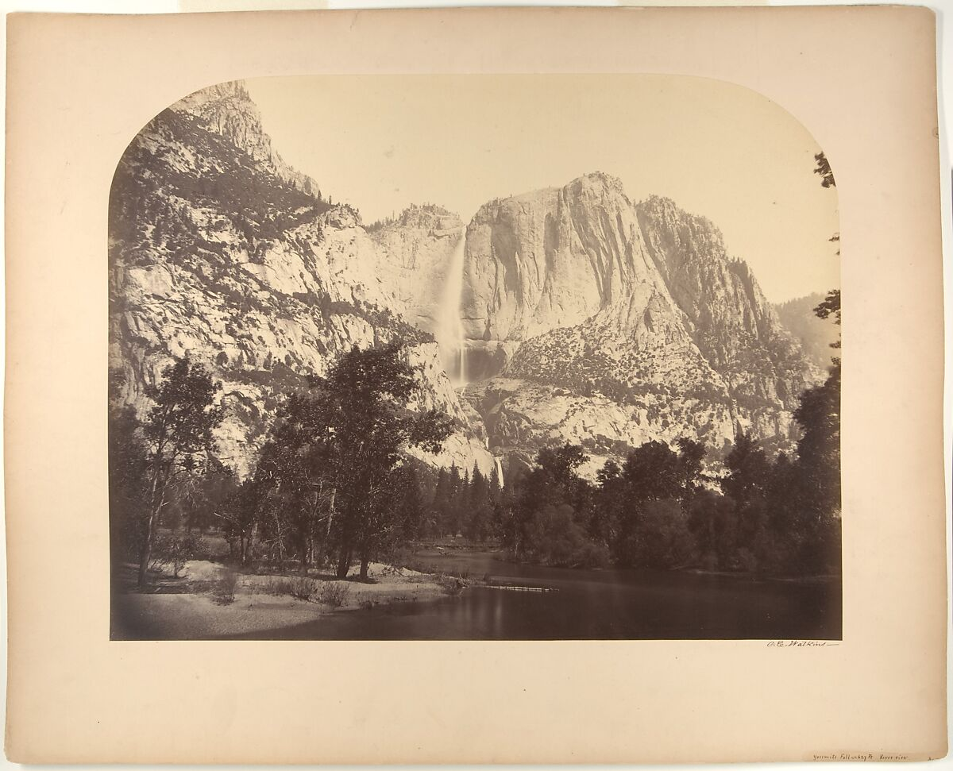

IMG-NAM0007. Carleton E. Watkins (American, 1829–1916), Yosemite Falls, River View, 2637 Feet, 1861, Albumen silver print from glass negative, Image: 16 1/2 × 19 1/2 in. (41.9 × 49.5 cm), Mount: 21 1/4 × 26 3/8 in. (54 × 67 cm). The Metropolitan Museum of Art.

2. Record Summary
Record ID | IMG-NAM0008
Original title | Yosemite Falls, River View, 2637 Feet
English title | Yosemite Falls, River View, 2637 Feet
Alternative title | N/A
Creator | Carleton E. Watkins
Creation date | ca. 1861
Country | United States
Cultural region | North America; California
Historical period | Mid-nineteenth-century United States; early landscape photography
Image type | Photography
Medium | Albumen silver print from glass negative
Dimensions | Image: 41.9 × 49.5 cm; mount: 54 × 67 cm
Primary subject | Waterfall and granite cliffs
Secondary subjects | River, trees, rocky valley and photographic mount
Source institution | The Metropolitan Museum of Art
Collection or object number (optional) | 2005.100.1274

3. Image Description

3.1 Short Description
A sepia-toned landscape photograph presents a high waterfall descending between steep granite cliffs. A calm river occupies the foreground, bordered by dark trees that frame the brighter rock face and falling water. The photographic image has rounded upper corners and is mounted on a larger cream-colored support.

3.2 Detailed Visual Description
The mounted photograph is shown as a complete rectangular object against a pale background. A broad band of still or slowly moving water fills the lower foreground and reflects dark tonal shapes. Trees and low vegetation stretch across the middle ground, with taller branches entering from both edges. Behind them, massive light-toned cliffs rise across the frame. A narrow waterfall drops from a high ledge near the centre-left and breaks into mist near its base.
The cliffs on the right form a large vertical wall with irregular cracks and ledges. Darker and more distant rock formations appear on the left. Only a small area of sky is visible above the cliff line. The monochrome image ranges from pale cream to deep brown, with its brightest areas concentrated on the waterfall and granite surfaces. No people, buildings, animals or legible text are visible within the landscape. Minor marks and signs of age appear on the surrounding mount.

4. Formal Features
Field | Analysis
Composition | A horizontal valley view is organised around the waterfall and bright granite wall, with trees forming a dark middle-ground frame.
Viewpoint or camera angle | The camera is positioned close to water level and faces across the river toward the cliffs.
Shot scale | Wide landscape view.
Spatial depth | Water, trees and cliffs create clearly separated foreground, middle-ground and background layers.
Lighting | Daylight illuminates the exposed rock surfaces while vegetation remains comparatively dark.
Colour palette | Warm monochrome brown, cream and charcoal tones.
Contrast | Strong tonal contrast separates the pale cliffs and waterfall from the dark tree line.
Visual focus | The waterfall is the primary focus; the large cliff wall is secondary.
Texture | Smooth water contrasts with dense foliage and sharply articulated granite.
Movement or stillness | The falling water implies vertical movement within an otherwise still landscape.
Medium-specific features | Fine albumen detail, warm tonal range and rounded corners on a mounted print are visible.

5. Historical Context and Purpose

5.1 Historical Context
Watkins produced this photograph during his 1861 work in Yosemite, when large-format landscape photography was becoming an important means of presenting western American scenery to viewers who could not visit it directly. The Met identifies the object as an albumen silver print made from a glass negative, a process capable of registering detailed rock, vegetation and water surfaces. The inclusion of the falls’ measured height in the title connects scenic representation with nineteenth-century practices of geographical description and documentation. The photograph is now held by The Met’s Department of Photographs. [IMG-0001-S01] Image Purpose and Circulation

5.2 Image Purpose and Circulation
Original purpose: Not verified.
Probable purpose: Artistic, documentary and commercial circulation among viewers interested in Yosemite and western American landscapes.
Current institutional use: Preservation and interpretation as an important historical example of American landscape photography.

